

Homework Cover Sheet

|  |  |
| --- | --- |
| Name: Rakesh Jain | Date: 03/01/2017 |
| Course: EGCP-541 | HW #: 4 |

Grading Criteria:

|  |  |  |
| --- | --- | --- |
| **Problem** | **Earned Points** | **Possible Points** |
| Problem 1: |  | 8 |
| Problem 2: |  | 8 |
| Problem 3: |  | 10 |
| Problem 4: |  | 8 |
| Total: | 0 | 34 |

**PLEASE UPLOAD YOUR HOMEWORK IN TITANIUM. NO PAPER SUBMISSIONS.**

Report Submission Instructions:

* Please, upload your HW report to TITANIum
* No paper submissions
* When showing your work, you can use MS Word’s equation tool. Or you can hand write your work, take a picture, and paste the image here. One app that I would suggest to easily do this is “CamScanner”.
* When giving the screenshots, please take a screenshot of the whole screen (i.e., include the OS taskbar, date, clock, etc.). No cropping.
* The point will be normalized to 100

1. (8 Points) Do problem 2.1 in the book. Use Matlab to create the two-sided magnitude plot of a sinusoid of frequency f0 with it’s first to images. Also, create the time-domain plot of this sinusoid, it’s alias, and the sample points. Provide any Matlab code to receive full credit.

MATLAB CODE:

%the t vector is analog time

t = 0:99;

%the n vector represents the sampling impulse train

n_1 = [1,zeros(1,9)];

n = [n_1, n_1, n_1, n_1, n_1, n_1, n_1, n_1, n_1, n_1];

%input = cos(2pi*fs/10) --> fs is sampling frequency

input = cos(t.*2*pi*1/11)+2;

input2 = cos(t.*2*pi*1./(10*(1/(1-1/1.1))))+2;

sampled_input = input.*n;

figure(1)

plot(t, input)

hold on

stem(t, sampled_input)

axis([0,99,0.5,3.5])

xlabel('Time')

ylabel('V')

hold off

figure(2)

stem(t, sampled_input)

axis([0,99,0.5,3.5])

xlabel('Time')

ylabel('V')

hold on

plot(t, input)

plot(t, input2, 'r:')

MATLAB SCREENSHOT

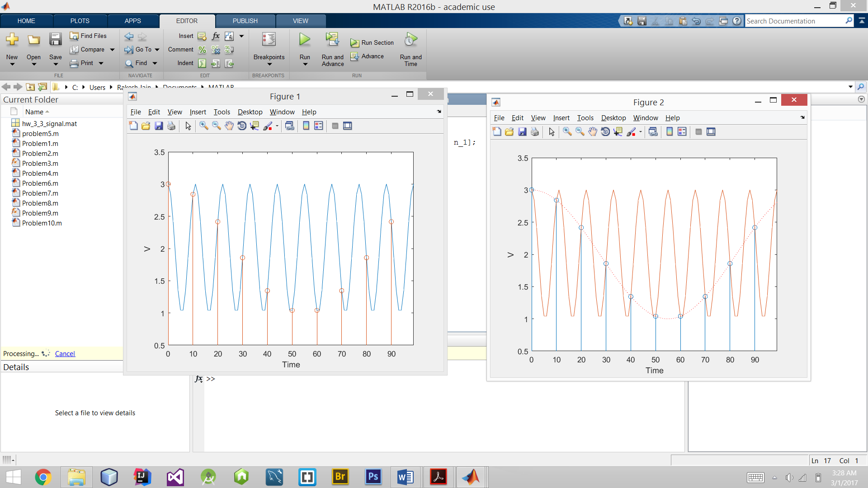

1. (8 Points) Do problem 2.2 in the book. Provide a brief explanation of what you did. Also, provide the truth table of the flip-flop outputs (Q0, Q1, and Q2). You can do the sketches by hand, take a picture, and paste the images here. One app that I would suggest to easily do this is “CamScanner”.
2. (10 Points) Do problem 2.4 in the book. Calculate the attenuation at 4 MHz and 96 MHz by hand for a single ideal sampler. What are the values that you calculated? Does having a cascade of samplers result in additional attenuation of the output? When showing your work, you can use MS Word’s equation tool. Or you can hand write your work, take a picture, and paste the image here. One app that I would suggest to easily do this is “CamScanner”.
3. (8 Points) Write a Matlab function called “zero_pad” that will zero-pad a digital signal. This function **must** be defined as follows:

**function** y **=** zero_pad**(**x**,**K**)**

% function y = zero_pad(x,K)

%

% Inputs: x - Input Signal

% K - Padding

%

% Output: y - Zero Padded Signal

%

Now, write a separate script that will do the following:

1. Use this function to zero-pad the signal “x” below.
2. Plot the input signal (“x”) and the zero-padded signal in subplots on the same figure (see Lecture 10 for an example).
3. Plot the magnitude responses for both the input signal (“x”) and the zero-padded signal in subplots of another (separate) figure.

Provide your Matlab code (both the “zero_pad” function and the script) and the two plots (time domain and magnitude response).

x = [0.7419, 0.4457, 0.3362, -0.6423, 0.1010, 0.9198, 0.1920, 0.6171, 0.9691, 0.7718, -0.5723, -0.9307,

-0.0978, -0.9724, -0.05258, 0.90239];

MATLAB CODE:

function y = zero_pad(x,k);

% Inputs

%Input Signal

x = [0.7419, 0.4457, 0.3362, -0.6423, 0.1010, 0.9198, 0.1920, 0.6171, 0.9691, 0.7718, -0.5723, -0.9307, -0.0978, -0.9724, -0.05258, 0.90239];

%Padding

k=4;

**Script:**

z=zeros(1,4*length(x));

a=x;

j=1;

for i=1:k:length(z)

z(i)=a(j);

j=j+1;

end

fs=1e3; % Frequency assumed

N=length(x);

M=length(z);

% FFT

nfft = 2.^nextpow2(N);% Next power of 2

nfft1 = 2.^nextpow2(M);% Next power of 2

%

X = fft(x,nfft);

Z = fft(z,nfft1);

% Magnitude (single sided)

f = linspace(0,fs/2,N/2);

f1 = linspace(0,fs/2,M/2);

magnitude_fft = abs(X(1:N/2));

magnitude_fft1 = abs(Z(1:M/2));

% Plot Magnitude

figure();

subplot(2,1,1);

plot(f,magnitude_fft);

hold on;

ylabel('Magnitude');

xlabel('Frequency (Hz)');

hold on;

subplot(2,1,2);

plot(f1,magnitude_fft1);

hold on;

ylabel('Magnitude');

xlabel('Frequency (Hz)');

%Linear Interpolation

b = 1:length(z);

n = 1:length(x);

n_up = 1:1/k:length(x);

y = interp1q(n',x',n_up')';

figure();

subplot(2,1,2);

stem(b,z);

xlabel ('i,Kt/Ts');

ylabel ('y[i*Ts/K]');

hold on;

subplot(2,1,1);

stem(n,x);

xlabel('n,t/Ts');

ylabel('x[nTs]');

figure();

subplot(2,1,1);

stem(n,x);

xlabel('n,t/Ts');

ylabel('x[nTs]');

hold on;

subplot(2,1,2);

stem(n_up,y);

xlabel ('i,Kt/Ts');

ylabel ('y[i*Ts/K]');

MATLAB Screenshot:

